Fundamentals of Hyperelasticity in Soft Tissue
Biological soft tissues are characterized as hyperelastic materials, which allow for the modeling of large deformations and inherently non-linear stress-strain relationships. In classical linear elasticity, the material response is governed by Hooke’s Law, where the stress-strain relationship is defined by a constant Young’s modulus representing the gradient of the stress-strain curve. In contrast, the mechanical behavior of a hyperelastic material is determined by a Strain Energy Density (SED) function, denoted as$Ψ$.
The state of stress within the material is derived directly from this energy potential. Specifically, the Second Piola-Kirchhoff (PK) stress tensor (S) is obtained by taking the derivative of the SED function with respect to the Right Cauchy-Green deformation tensor (C):
$$S=2\frac{∂Ψ}{∂C}$$
While first PK stress is a measure of force (defined in current configuration) per unit area (defined in reference configuration), but it is not symmetrical and so not convenient for computation. Therefore, Second PK stress is used for computation. It doesn’t have physical meaning; it is used because it is symmetric and computational convenient.
From the Second PK stress, the physical Cauchy stress ($σ$) in the current configuration can be calculated using a push-forward transformation (move it from the reference frame to current frame):
$$σ=J^{-1}FSF^{T}$$
where F is the deformation gradient. F is a fundamental kinematic tensor that maps the undeformed (reference) configuration to the deformed (current) configuration, essentially describing the total change in the geometry of the material element.
Strain Energy Density and Invariants
The SED function is typically formulated using strain invariants derived from the deformation gradient. While F contains all information regarding the configuration change (including rigid body rotations) a material does not "feel" stretch or develop internal stress during pure rotation. Therefore, invariants are calculated from the Right Cauchy-Green tensor ($C =F^{T}F$) to eliminate the rotational components, leaving only the "stretch" that the material can physically sense.
A common example of a simple SED function is the Neo-Hookean model, which describes isotropic materials:
$$Ψ=\frac{μ}{2}\left(I_{1}-3\right)$$
In this framework, the invariants $I_{1},I_{2},I_{3}$ represent isotropic properties, while $I_{4},I_{5},I_{6}$ account for anisotropic behavior, such as fiber reinforcement. The following table details the calculation of these invariants:
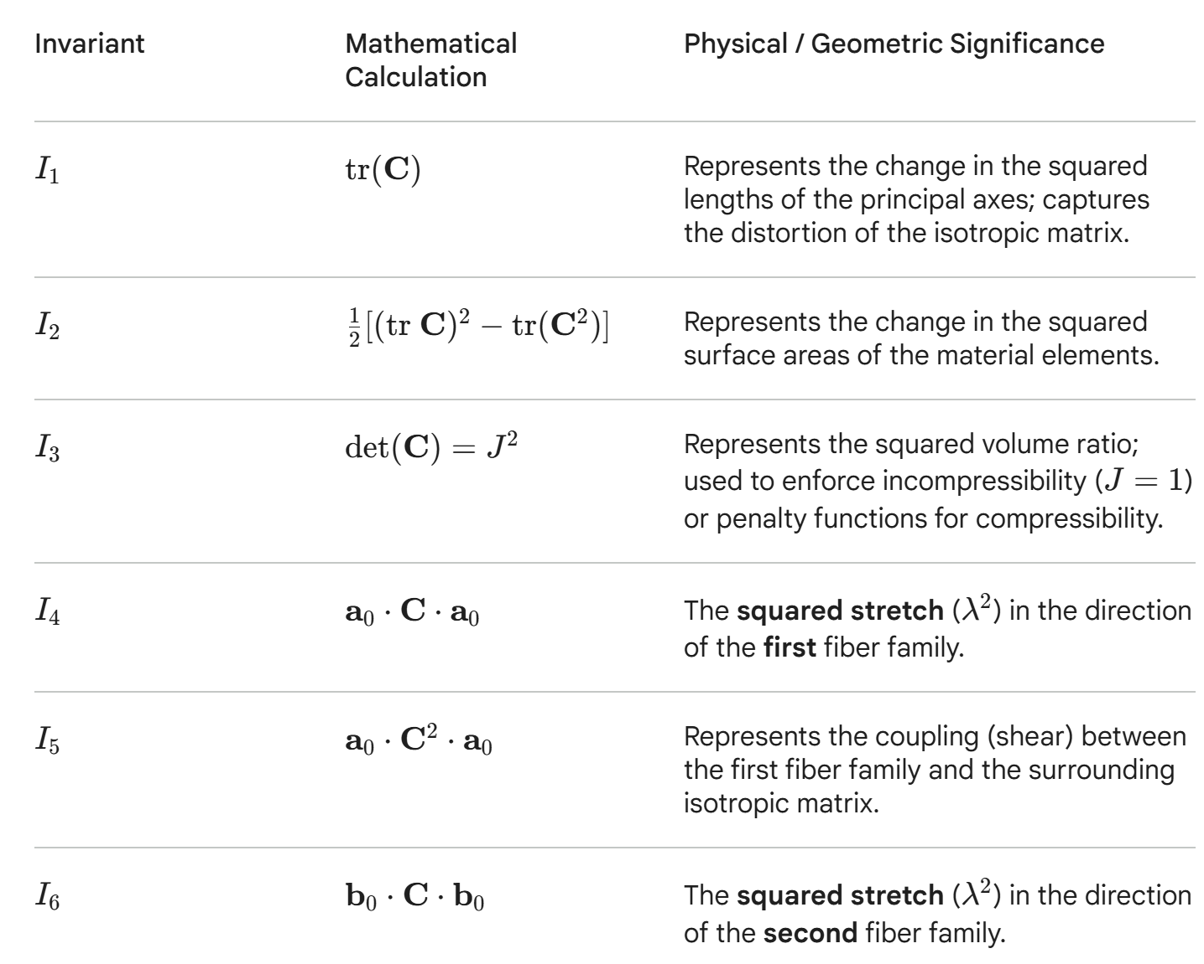
Some specificmathematic operators:
Dyadic product: $n⊗n$
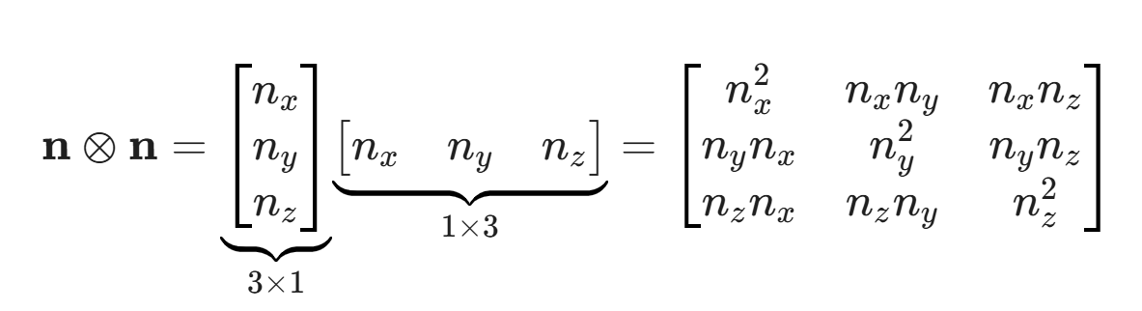
The dyadic product turns a simple Direction (1D arrow) into Structural (3D tensor). A vector may be enough to specify the direction for human understanding, it is not enough for the matrix math. Therefore, transformation of vector into a tensor is necessary. The 3D tensor is used to ensure that “something” only occur in this direction or “only do something in this direction”. If there is only a number (scalar) to describe a growth property, it will affect the material in all directions, like inflating a ballon. In order to model the contribution from a collagen fibril, $n⊗n$ must be used to specify its anisotropic properties.

Double dot product:
By multiplying every single element of the first matrix by the corresponding element of the second matrix and adding them all together, you will get a scalar.
The double dot product between the structural tensor H and the Right Cauchy-Green tensor C quantifies the degree to which the tissue is being stretched specifically along the axes defined by the collagen fibers. In this relationship, H acts as the structural map of fiber orientations, while C represents the total deformation state of the tissue.

For example, if a tissue is being stretched in X direction, while H is pointing to Y direction, the fibers will not “feel” anything, and the double dot product will be very small or zero. Conversely, if a tissue is being stretched in X direction and H is also pointing to X direction, the result of H:C will be large.

My understanding in G&R:
Two processes are thought to be involved in growth and remodeling process. Growth: change in geometry, usually due to the dynamic of deposit and removal of collagen fibril, causing a volumetric growth[1][2][3][7].
Remodeling: change in material properties; the change in microstructure of collagen network is thought to be the key contributor[11][12][13]. Think about if the strength of the collagen network is anisotropic, and it is given by the orientation of the collagen network. If this orientation reorganizes under loading, the anisotropic property would also change, and, consequently, its mechanical properties.

The main difference between collagen and elastin is that collagen’s modulus is higher and responsible for the main load bearing structure of the tissue. Elastin is flexible, it can be stretched in large strain and recover to its original dimension.
A study from HA Quigley [15] found that elastin appearance is correlated with stages of glaucoma. Normal eye would have a straight appearance and glaucoma eye would have a curled appearance. There is another study found that in glaucoma eye, the newly synthesized elastin appears in granular structure rather than tubular structure [16]. Quigley et. Al. [15] hypothesized that elastin is like a spring, when it is connected to other component, it appears to be straight; when it is detached from other component, it curled up. I am thinking elastin might be the key factor why laminar cribrosa at the end stage of glaucoma would collapse, compared to the LC thickening that has been observed in early stage of glaucoma. At early stage of glaucoma, the elastin is still functioning, so it can help the LC to restore/maintain its shape. When collagen is constantly being deposited and removed, it can growth in volume, hence thickening. But as glaucoma progresses, elastin lose it function eventually, it loses the elasticity and can no longer hold the LC together and help it to restore its shape. Therefore, it collapses and thinning of LC is observed at the end stage of glaucoma. Maybe we need an equation to capture this change of elastin? Like the loss of elastin is a threshold to determine when would LC start thinning.

I was thinking whether creeping can be used to replace the growth part( change in geometry) since it has time dependence. However, with creeping we cannot account for volumetric growth (thickening or thinning), their principle is different. Creeping does not account for the continuous deposit and removal of collagen. So even though creeping also demonstrates the change in geometry as time progresses, it is not suitable.

Two main approaches in growth and remodeling: kinematic and constrained mixture model. Kinematic models describe that the total deformation gradient ($F)$in growth and remodeling phenomenon can be decomposed into elastic deformation gradient ($F_{e})$ and growth deformation gradient ($F_{g})$
$$F=F_{e}*F_{g}$$

While constrained mixture model describes G&R tissue is a mixture of n structurally significant constituents [3], each constituent has their own deposition and removal equations, but they deform with the tissue as a whole.

Kinematic approach is usually simple and computational efficient, this method is able to capture the “growth” part (usually refer to change in geometry), but not able to capture the “remodeling” part. It does not account for mass turnover (which a few papers [1][3]mentioned that growth and remodeling is involve of the balance of deposit and removal of a material), since it does not capture this key feature, the material properties in kinematic approach is usually constant.

On the other hand, constrained mixture model, the idea is that multiple significant constituents form a “mixture”, each constituents are allowed to have their own properties and configuration, (like you can describe this mixture has collagen fiber, ECM, smooth muscle fiber, and what are their individual material properties, these individuals properties of every constituents then combine and form the material properties of that mixture). This method can model the mass turnover. However, this method is computationally expensive, and lot of complicated equations are involved.

Now I am using kinematic approach in my model, let’s say it is able to capture the growth part, this method is like fundamentally missing the remodeling part. Maybe I could make the $F=F_{e}*F_{g}$equation into $F=F_{e}*F_{g}*F_{r}$, adding a remodeling tensor to fill in that gap?
Updated: I think Rafael 2012 study[1] can actually fulfill both “growth” and “remodeling” features. In his Kinematic approach, he already includes collagen fibril mass turnover in the growth tensor ($Fg$). However, when it comes to the generalized structural tensor (H), he set this to be constant along the modeling progress. In his earlier work [12], he demonstrated that the reorientation of collagen fibril in LC can be achieved via updating the direction of the generalized structural tensor H. I am not sure why he didn’t put these two features together in this study [1]. Maybe it’s the computational efficiency issue? I don’t think he mentioned this in his study.

One paper has deepened my understanding of how to account for the remodeling part. It mentioned that” These new fibers are deposited using their homeostatic stretch level. This stretch is lower than that of the removed collagen fibers, causing a change in intrinsic material stiffness, leading the vessel wall to bulge out under a continuous loading” [7]. This is like the mass turnover of constrained mixture approach, continuously deposit and removal of a material. If the pre-stretch level of some fraction of a constituent is different, this will then contribute to the difference in the “mixture” level, causing the material properties such as stiffness to change.

What I can potentially do:
So far, I have not seen study using FE model to predict the whole process of G&R. Majority of study only apply G&R on an identical geometry but rather than patient specific case (there is study [10] using patient specific LC geometry, but that is not for G&R). So I think no one has done what we want to achieve, which is obtaining OCT scan from patient and building the mesh from it, then perform G&R prediction for the entire progression of glaucoma.

Concern:
Even if the model finally works, it can replicate the change of patient A glaucoma progression, it doesn’t mean that this model would also work for patient B.
But what we can do after that is to train AI model, feed it with enough data of OCT scan that it learn how to adjust the parameters base on different geometry of the ONH before glaucoma progression (suggested by Ting Ting). So the ultimate goal would be, input an OCT scan to an AI model, that model use the growth and remodeling law that assigned to it, it is like a general laws for LC changes in glaucoma, then the AI look at the geometry of the OCT scan, spot the pattern, automatically adjust the parameters and use the model to give predictions.

Details on the models (equations) used in other studies:
Remodeling part:
In this computational framework [11], the authors aim to investigate the reorientation of collagen fibril in artery. They evaluate each material point within their model, which can be viewed as a discrete part of an element that deforms and moves alongside it. This approach allows for consistent tracking of the element throughout the simulation. At each material point, the stress state is calculated, and the resulting principal stresses ($σ_{1}$ and $σ_{1}$) are used to determine $γ$, an angle representing the principal stress direction.
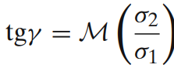
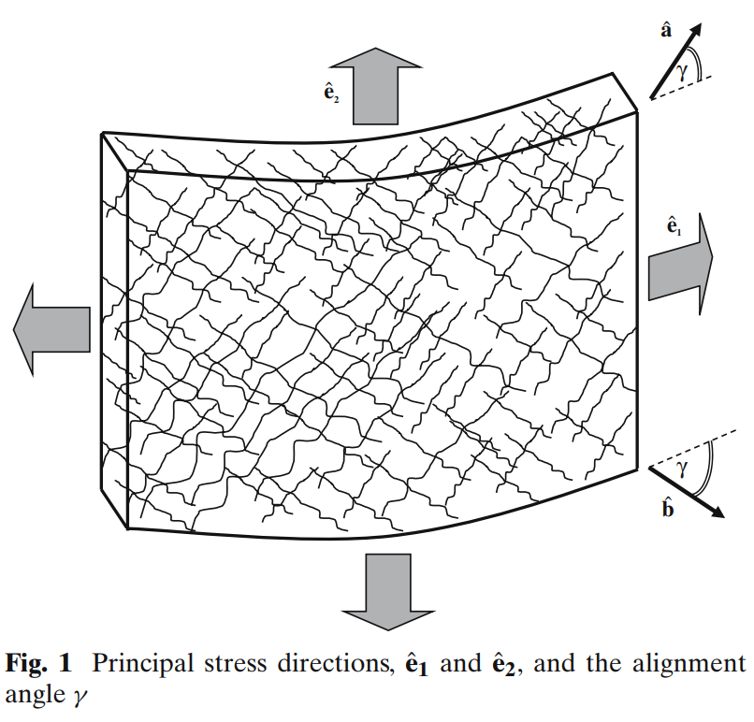
The core assumption of the model is that collagen fibers align their axes with these principal stress directions. Consequently, $γ$ serves as the mathematical link between the principal stress directions ($e_{1}, e_{2}$) and the material coordinate system (a,b). By establishing this relationship, the model can iteratively update and track the orientation of the collagen fibers for each subsequent step of the simulation.
The workflow is: the ratio of principle stresses can give you a set of vectors (a,b) 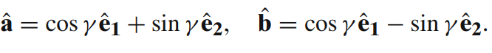
This can translate into unit vectors
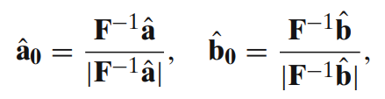
Then used to find the invariant$I1, I4 , I6$ and the strain energy density equation
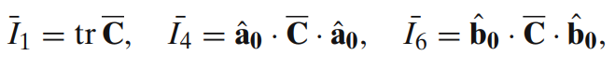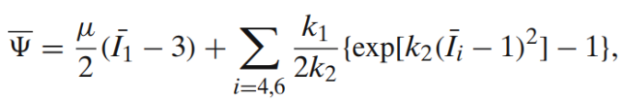

A study from Rafael [13] adopted the idea from [11] that collagen fibril oriented along with the two maximum principal stresses and aim to apply it to the eye model. Rafael assumed the material behavior of collagen network in the sclera can be approximated by two families of two-dimensional dispersed collagen fibrils. They also assume the collagen fibril disperses by means of normalized von Mises distribution function.
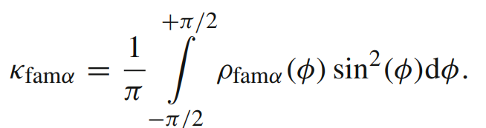
To visualize how the collagen family distributed,
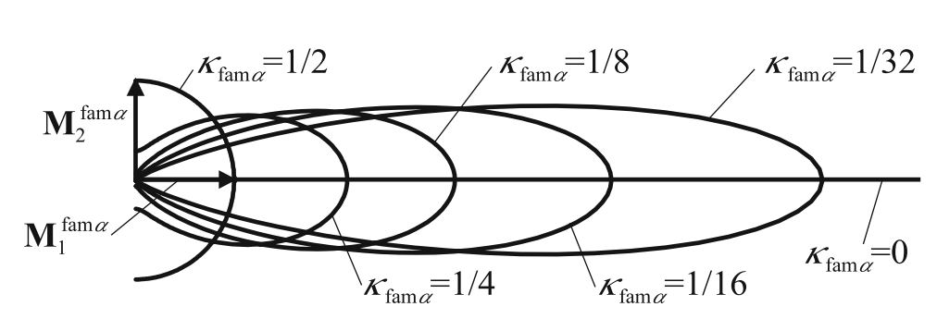
k=0: collagen fibril family perfectly align with the mean orientation
k=0.5: collagen fibril distributed isotopically

The orientation of individual collagen fibril is e0, it is described by the following equation:
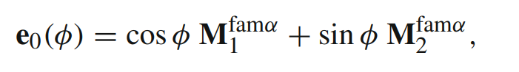

The ratio of the two maximum principal stresses gives a target vector of the mean fibril direction, then an algorithm is used to update M, the mean fibril orientation, base on this target vector. M then used to calculate the generalized structure tensor H.
The generalized structure tensor is described as:
This generalized structure tensor gives directional information and C gives stretch information. ($\sqrt{H:C}$ ) this tells how the stretch is applied in certain direction.

The strain energy density is composed of 1 isotropic and 2 anisotropic terms:
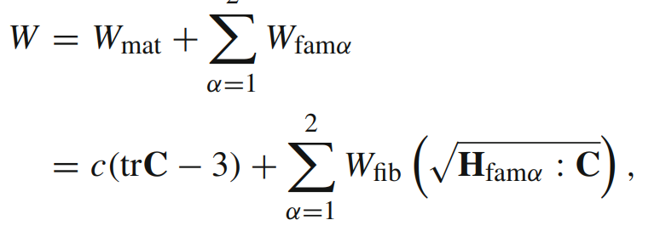
The contribution of individual collagen fibril appears on the $W_{fib}$ term in the SED equation.

To summarize, the workflow is:
Stress > target vector > Pull back > rotate M > Update H > New stiffness
and loop again

Subsequent study from Rafael [12] considered collagen fibril remodeling in laminar cribrosa. They used a very similar method of their previous study [13] to conduct the simulation. The remodeling happened on the orientation of collagen only; the fibril diameter, initial crimp shape, collagen content is constant.

Their model assumes that the collagen network is initially isotropic. When IOP is elevated, the collagen in the peripapillary sclera (PPS) first remodels into a circumferential ring. This configuration shields the optic nerve head (ONH) from high tensile stresses, reducing the scleral canal expansion from 41 micro-meter to just 5 micro-meter. However, this transformation also converts membrane deformation (in-plane stretching) into bending, which induces cupping and generates high shear stress. Subsequently, the collagen fibers in the lamina cribrosa (LC) begin to reorient in a radial direction to mitigate this bending.
This remodeling process brings the maximum principal stress/IOP ratio down from 17.5 to 8.1, while simultaneously increasing the in-plane shear stress/IOP ratio from 0.4 to 4.2.
They found that this radial reorientation reduces the cupping of the LC to a height of 72 micro-meter, which is consistent with the physiological range of 30–77 micro-meter measured by Yang et al. (2009).

Growth part:
A review paper [14] mentioned that the main difference between soft tissue and hard tissue modeling is that soft tissue usually due with 1)large deformation ;2) soft tissue model tend to be oversimplified when their multi-phase material characteristic reduced to single phase (unlike bone, which is also a multiphase material, but modeling only the solid phase is sufficient in majority of the application ; 3) soft tissue is difficult to preserve and the ex vivo response might be very different compared to in vivo response.

They highlight a general growth law:
$$F_{g}= θ_{iso}I+\left[θ_{ani}-1\right]n⊗n$$
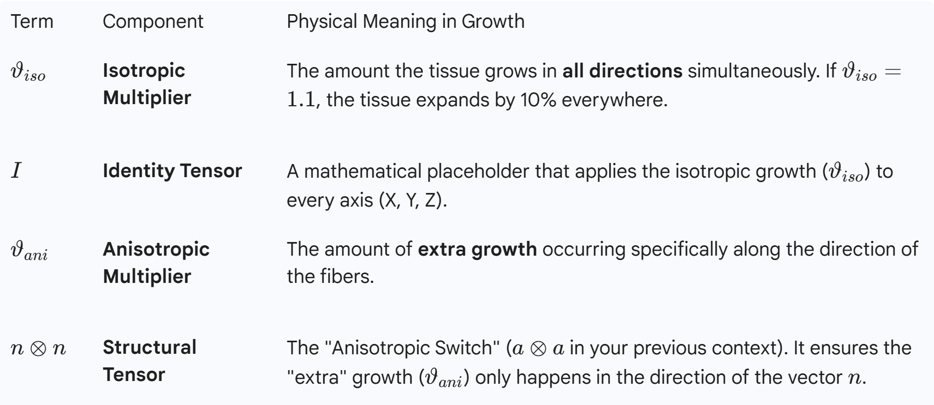
For different applications, the theta is different,
Volumetric growth: $ϑ_{iso}= θ_{g} ; θ_{ani}=1$
Area growth: $ϑ_{iso}= \sqrt{θ_{g}} ; θ_{ani}=2-\sqrt{θ_{g}}$
Fiber growth: $ϑ_{iso}= 1 ; θ_{ani}=θ_{g}$
We will need fiber growth (for collagen fibril), and potentially volumetric growth (the bulk of LC) to model the growth part.

A computational study on carotid artery [6] proposed a strain energy function decomposed into volumetric and isochoric parts. Volumetric represents the changes in volume( larger, smaller) while the shape of the object remains unchanged. Isochoric part describes the changes in shape (shear, elongation…)
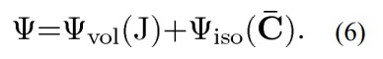
The isochoric contribution is further decomposed into an isotropic contribution of elastin and anisotropic contribution of collagen fibril.
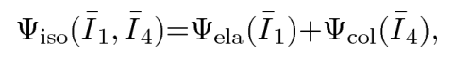
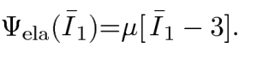+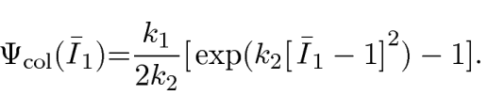
After obtaining the strain energy function, it can be differentiated with respect to right Cauchy green deformation to obtain the second PK stress tensor (S)
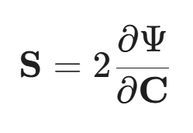
Second PK stress tensor is in reference configuration, to calculate the Cauchy stress in the current configuration,
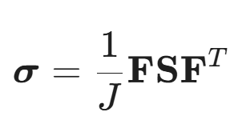
They decompose the total deformation into elastic (Fe) and growth (Fg), and use a growth multiplier $θ_{g}$ is used to determine the magnitude of growth. As $θ_{g}$ increase, Fg increases; hence Fe will decrease. This is how the growth part “help” to account for the increase of stress.

They consider only fiber growth in this model, hence the general growth law mentioned previously becomes
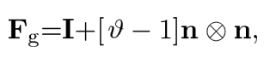
$n⊗n$ is to specify the direction of the anisotropic part of the equation (it ensures that $θ$ only affects in this direction). The growth multiplier is defined as
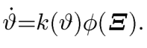 and 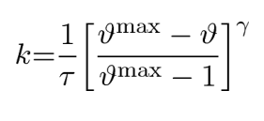
phi is a stimulus (stress or strain). The rate of change of theta can be multiplied with the time step, to get a “new theta”, which is then substituted back to the Fg equation.
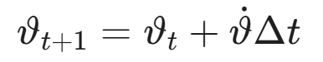

Their main finding is that stress driven approach would predict thickening at the outer wall of the artery, while strain driven approach would predict thickening at the inner wall (consistent with experimental observations). Therefore, the mechanical stimulus should be the stretch sensed by smooth muscle cell.

Rafael 2012 paper [1], they use a modified kinematic growth model (they still use $F=F_{e}*F_{g}$. In addition, they include some constituent approach in the growth law. They have also modified the strain energy equation, their strain energy equation is contributed by a few constituents, and it is linearly dependent on each constituent’s volume fraction defined at the grown configuration. *Overall, their kinematic approach is actually more like constrained mixture method) which they claim that this method can model collagen fiber recruitment (like the mass turnover). *Noted that their approach is strain-driven, which is different from what we thought that the G&R of LC is stress-driven.
They did not prescribe LC structure in their initial configuration, but their model predicts that as IOP increases, a LC structure will be created by their tissue recruitment algorithm, and the LC structure will span across the sclera canal. When further increases the IOP, the LC structure’s volume will keep increasing.

The mechanical stimulus is the stretch of collagen fibril at micro-scale
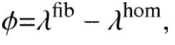
They consider collagen crimping with this equation. Therefore, magnitude of $λ^{fib}$ (which the actual stretching sense by collagen fibril) is alway smaller than $λ^{axial}$.
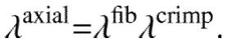
They also consider residual strain $λ_{R}$, which is the pre-stress between collagen fibril and its surrounding matrix. It can be thought of the constant deposit and removal of collagen (mass turnover) introduce collagen fibril at different pre-stress levels. When they come and interact with each other, the pre-stress of one collagen fibril may be higher than the other fibril, hence, it will stretch the other fibril even under stress-free conditions.
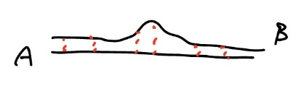
*Since fibril A is under higher tension, and it is linked to a newly synthesis fibril B. Fibril A is introducing a load on fibril B.
They assume 1) axon, 2) matrix, 3) fibril all deformed at the same level. Hence,
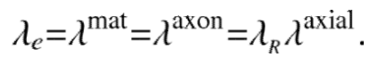
And $λ_{R}$ is defined as,
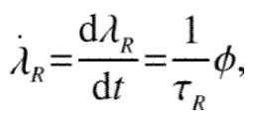

They decompose the total deformation into elastic part and growth part
$$F=F_{e}F_{g}$$
The Jacobian (change in volume) of it is,
$$J=J_{e}J_{g}$$
They used the fiber growth form of the general growth law mentioned previously,
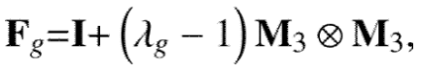
By taking the Jacobian, it becomes
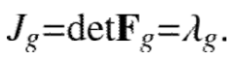
So, the change in volume due to growth is directly related to the growth multiplier $λ_{g}$ only.

They introduced a concept of volume fraction, essentially gives information of how much material A occupies the whole space.
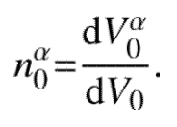
And the change of volume of a single material
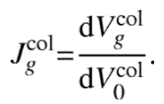
They have this equation to describe how the change of volume of certain materials affects the change of volume of the bulk material.
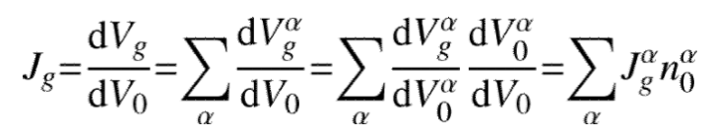
Since they assume axon and matrix is constant throughout the G&R process, their Jacobian is 1. Therefore, the change in volume of the bulk material is only contributed by the change in volume of collagen fibril.
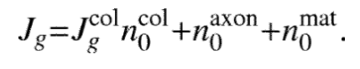
Noted that the change in volume of collagen would affect the volume fraction of other materials. so the volume fraction at grown configuration is
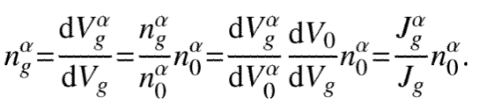
If axon volume is constant all the time, $J_{g}^{axon}$ is 1, when the tissue is growing because of collagen, $J_{g}$ >1. Hence, the ratio of axon decreases ($ie. \frac{1}{1.2} n_{0}^{axon}$)

To get $J_{g}$, $J_{g}^{col}$ is the key variable. The authors assume that the collagen fibril mass density is constant, and the changes in collagen content is only due to the number of collagen fibrils.
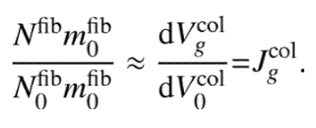
They described the rate of change of $J_{g}^{col}$ is based on the mechanical stimulus $ϕ$ and a function $k^{col}$
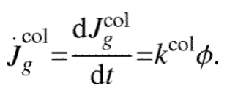
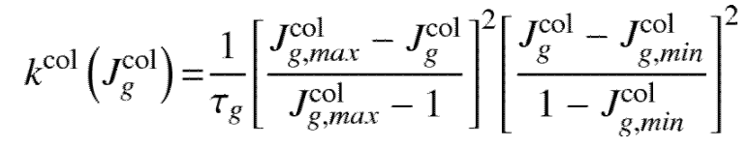
Essentially, the rate of volume change of collagen ${\dot{J}}_{g}^{col}$ is a function of itself $J_{g}^{col}$. The form of the equation is very similar the one used in the blood vessel study[6] mentioned previously.
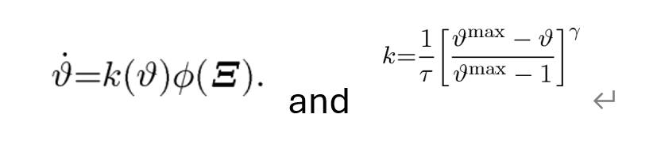

Constitutive equation:
They describe the strain energy density equation contributed by axon, matrix, and collagen. Differ from other study [6], this SED changes along with the modeling. It is dependent on the collagen content at the current state.
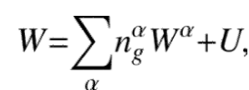
The volume fraction of material A is a ratio or percentage. It adjusts how much strain energy contribution of material A $W^{a}$ actually contribute to the whole tissue. Since they assume the content of axon and matrix do not change during modeling. The equation becomes,
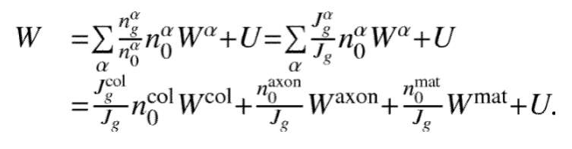
Recall that

So the strain energy equation is essentially a function of $J_{g}^{col}$
Similar to other study [13]. They use generalized structure tensor H and right Cauchy green C to calculate the overall stretch of collagen fibril family.
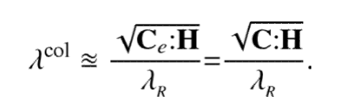
*divided by residual strain to obtain the “real” stretch which the collagen fibril can sense
Unlike their previous study [13], they assume H is constant throughout the modeling. Which means that they did not account for the reorientation of collagen fibril family (M , the mean direction of collagen fiber does not change).

Their model predicts for a given IOP, a larger globe would lead to a higher mechanical loading of the neural canal tissue, hence a thicker LC. And for a smaller globe, the mechanical loading is so low that the LC structure does not appear (like ONH of rodents)

Key findings from other studies:
A series of papers from Ellen Kuhl [4][5][6] have shown that they can use the same general form of growth law (just slightly change the parameter) for both skin tissue and carotid artery to obtain results that is well-agree with the experiment data (* noted that the energy equation is different).
$$F_{g}= θ_{iso}I+\left[θ_{ani}-1\right]n⊗n$$
$$\dot{θ}=k\left(θ\right)*stimuli$$
$$k={\frac{1}{τ}\left[\frac{θ^{max}-θ}{θ^{max}-1}\right]}^{γ}$$
For skin tissue, since the growth is “area growth”, the growth law becomes:
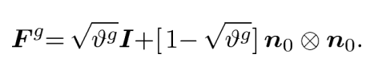
And for artery, the growth is “fiber growth”, hence the growth law becomes:
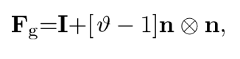
They can even change the growth tensor $F_{g}$, into an atrophy tensor $F_{a}$ in one of their studies (with a few additional equations that describe protein spreading) to predict brain volume loss in Alzheimer’s disease.

This computational study [8] utilizes FE analysis to investigate the biomechanical response of the Optic Nerve Head (ONH) using a linear, isotropic, and homogeneous model. The research aims to identify the primary drivers of ONH biomechanics by evaluating nine specific factors: the material properties and geometry of the sclera (modulus, radius, and shell thickness), the lamina cribrosa (LC) (modulus and radius), the pre-lamina neural tissue (PLNT) (modulus and compressibility), the optic nerve (modulus), and the level of intraocular pressure (IOP).
The study [8] concludes that ONH biomechanics are most significantly influenced by the elastic moduli of the sclera and the LC. In contrast, the geometry of the optic disc cup was found to have only a marginal impact. Furthermore, the authors established that significant interactions exist between these variables; for instance, the influence of eye size, shell thickness, and LC radius varies depending on whether the sclera is stiff or compliant.

In myopia, the remodeling is driven by visual stimuli [9]. Myopia can increase the risk of glaucoma in two ways: 1) Asymmetric ONH remodeling in childhood myopia tends to induce pathologic ONH remodeling even at normal IOP level in later life. Ageing is suggested to correlate with the risk of pathologic ONH remodeling of the myopic eyes. 2) accumulation of neural tissue deformation from the remodeling of ONH in myopia also increases the risk of insult of RGCs.

The first study [10] incorporates the complete and patient-specific LC microstructure into a macro-scale FE model of human eye. Binary images of LC are stacked in a volume representing the entire LC microstructure. Key finding is microstructural model with a simple isotropic neo-Hookean hyperelastic material model that can better estimate the complex mechanical response of the LC under IOP elevation by capturing structural heterogeneity using accurate modeling of the collagenous microstructure.
Therefore, microstructure of LC must be considered as they found huge difference when you consider LC is a simplified geometry (homogenous block of element). When you also consider microstructure, the stress is several times higher. Might explain why someone develops glaucoma in normal IOP, because their specific microstructure maybe tend to have a high stress or strain concentration.

A homogenized constrained mixture model [3] by Humphrey in 2016, they claim this modified constrained mixture model is equivalent to classical constrained mixture model in linear regime. The advantage of this modified model is that it is computationally efficient. They consider the growth and remodeling process of soft tissue as nonlinear viscoelastic which can be represented by a mechanical analog model consisting of Maxwell fluid in parallel with a motor-element that models cell-mediated Mechan regulation of matrix.
However, they mentioned that “This temporal homogenization by assuming that mass turnover does not change the general mechanical behavior of constituent (its strain energy function) but only its average stress-free configuration.” Does that mean that this simplified constrained mixture model is missing a key part which makes it cannot capture the change in material properties?

In a study from Ellen Kuhl et al [7], they tried to find out which approach (kinematic or constrained mixture model) is better, so they model the same experiment in pulmonary autograft with both approaches. Their conclusion is constrained mixture model is better.
The kinematic model predicts increase in mass while the constrained mixture model predicts decrease in collagen fraction leading to decrease in mass. The experimental results show an increase in collagen mainly due to inflammation deposition. However, the medial thickness decreases. This means that kinematic model is not suitable because both model doesn’t account for inflammation so the correct one should predict a decrease in mass.
They also said further investigation into the triggers of growth in the kinematic approach can possibly overcome this issue, but based on so far what they have done, their kinematic model is not suitable for this experiment.

References:
[1] Laminar cribrosa thickening in early glaucoma predicted by a microstructure motivated growth and remodeling approach
[2] Perspectives on biomechanical growth and remodeling mechanisms in glaucoma
[3] A homogenized constrained mixture (and mechanical analog) model for growth and remodeling of soft tissue
[4] The interplay of biochemical and biomechanical degeneration in Alzheimer's disease
[5] Growth on demand: Reviewing the mechanobiology of stretched skin
[6] Computational modeling of hypertensive growth in the human carotid artery
[7] Growth and remodeling in the pulmonary autograft: computational evaluation using kinematic growth models and constrained mixture theory.
[8] Interactions between geometry and mechanical properties on the optic nerve head
[9] Connective Tissue Remodeling in Myopia and its potential role in increasing risk of glaucoma
[10] Modeling the biomechanics of the lamina cribrosa microstructure in the human eye
[11] Stress-driven collagen fiber remodeling in arterial walls
[12] The collagen fibril architecture in the lamina cribrosa and peripapillary sclera predicted by a computational remodeling approach
[13] A computational remodeling approach to predict the physiological architecture of the collagen fibril network in corneo-scleral shells.
[14] Frontiers in growth and remodeling
[15] Alterations in elastin of the optic nerve head in human and experimental glaucoma
[16] Ultrastructural immunocytochemical analysis of elastin in the human laminar cribrosa

